**CLOUD COMPUTING**

**ASSIGNMENT - 1**

**BARATHADHITHIYA BALAKRISHNAN SUNDARAMOORTHY (M13506318)**

**DNS : ec2-3-15-205-227.us-east-2.compute.amazonaws.com**

**Server DNS** : ec2-3-15-205-227.us-east-2.compute.amazonaws.com

EC2 instance is up and running and web server configured:

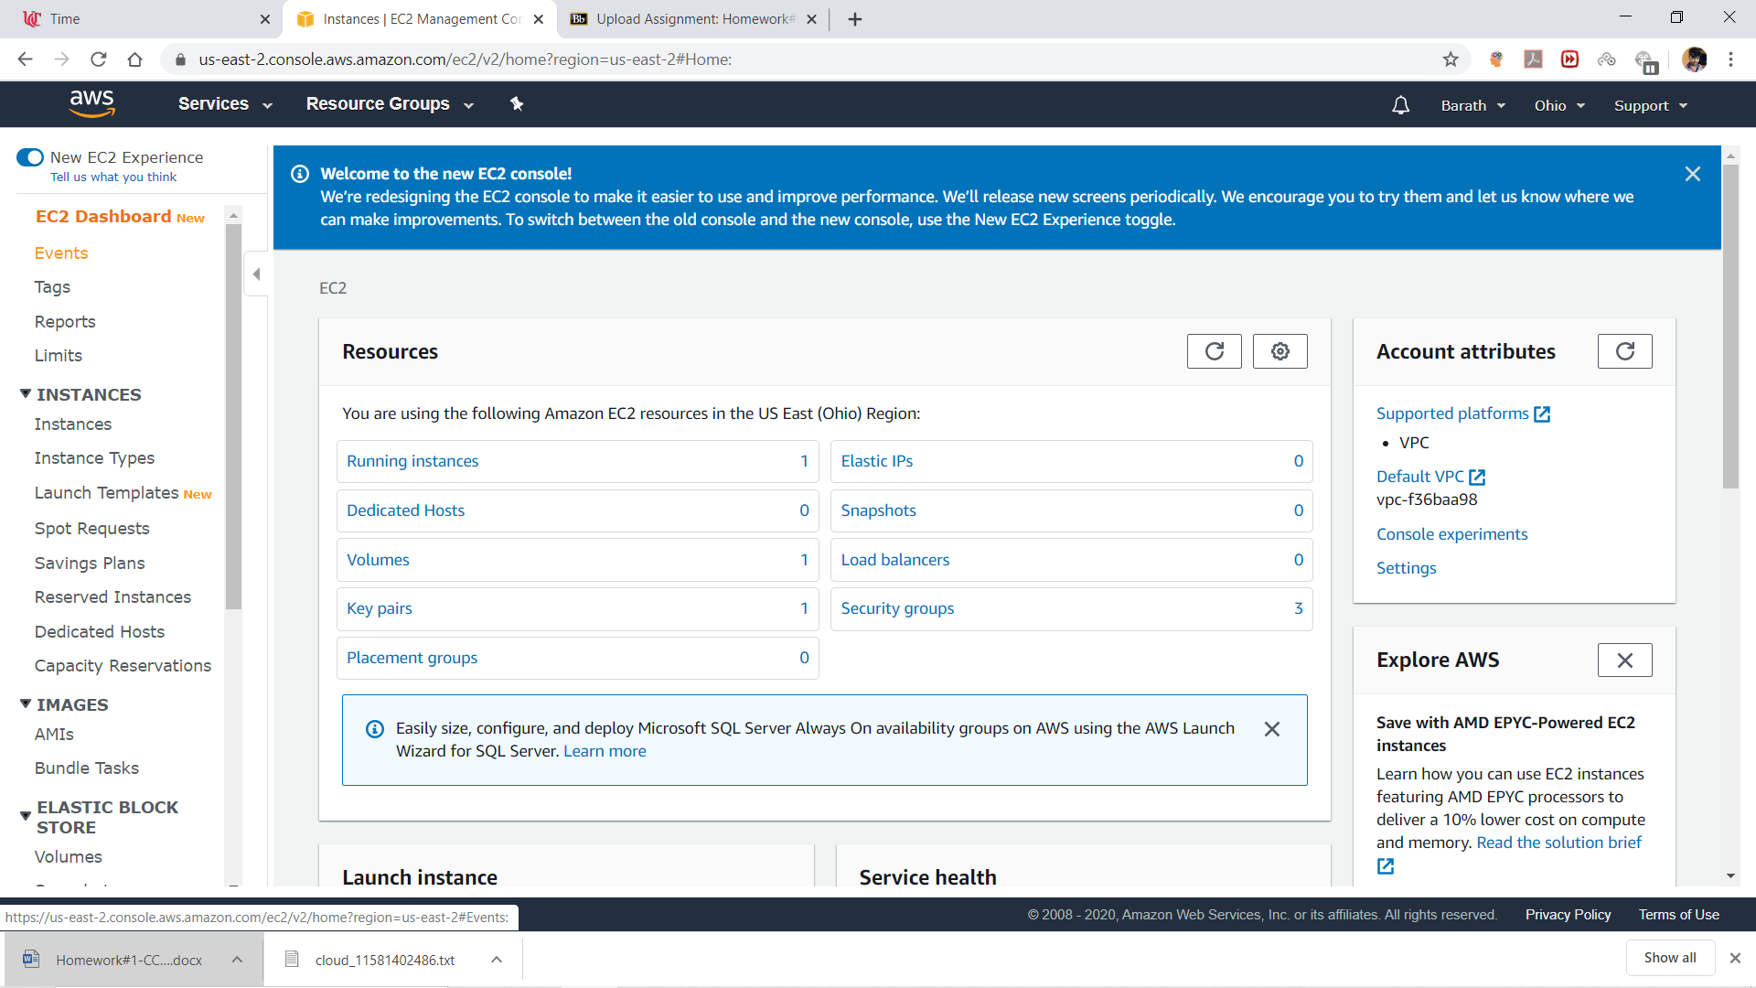

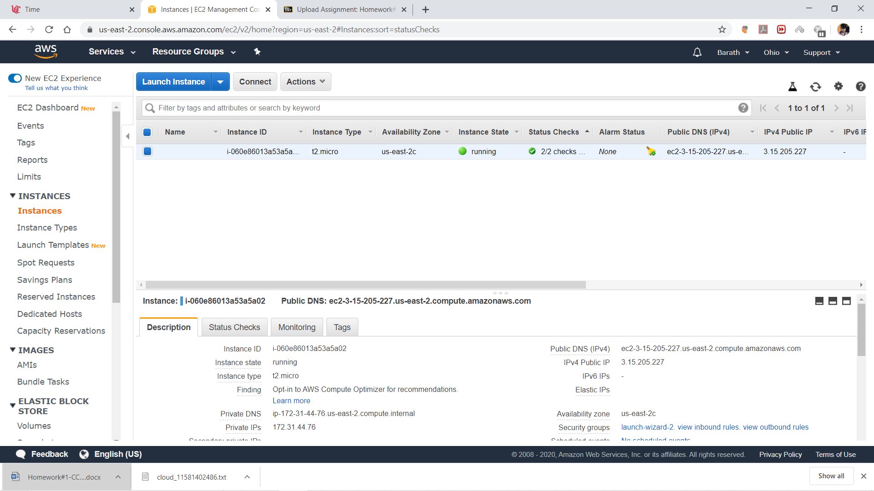

Below is the UI for log-in after hitting on the DNS server:

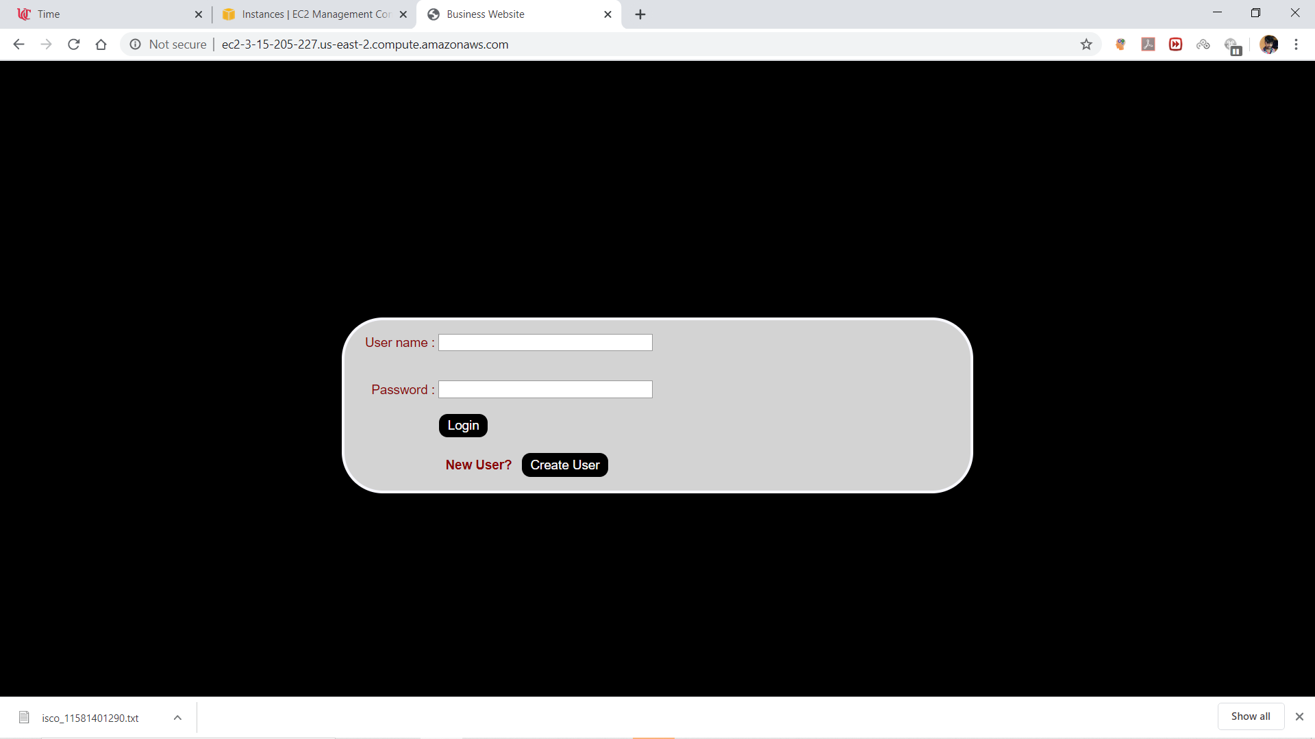

Below screenshot shows that I can be able to type something in username and password fields

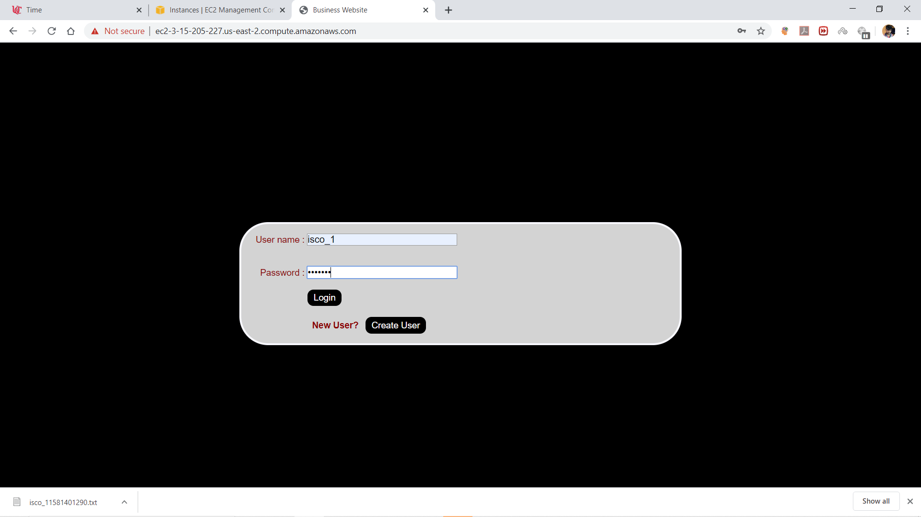

Below screenshot shows that, details have been displayed for that logging user after hitting Log-in button

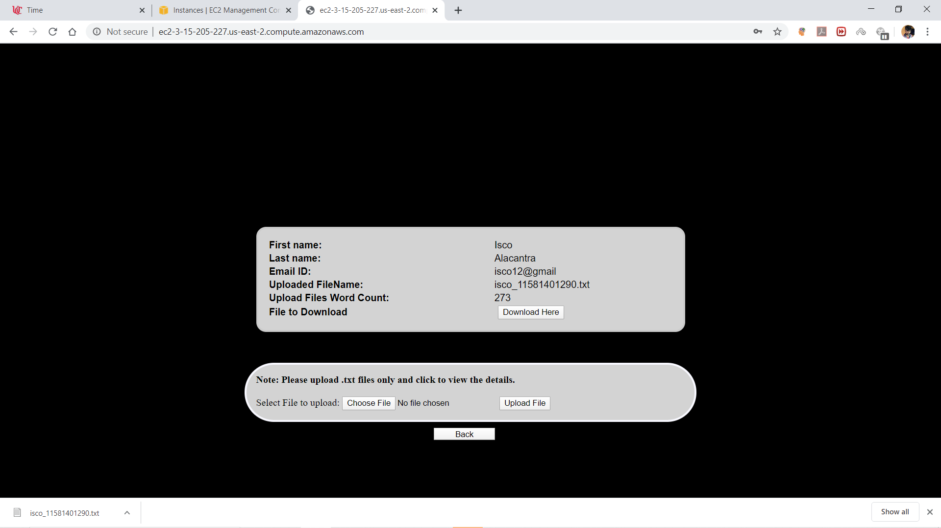

As we can see file is already uploaded and it shows word count and file name.

Below screenshot shows that choosing an .txt file

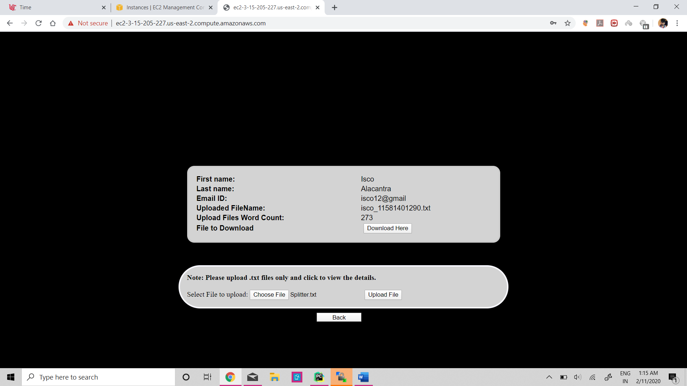

Below shows that filename and word count are updated as per new file after clicking ‘upload file’ button

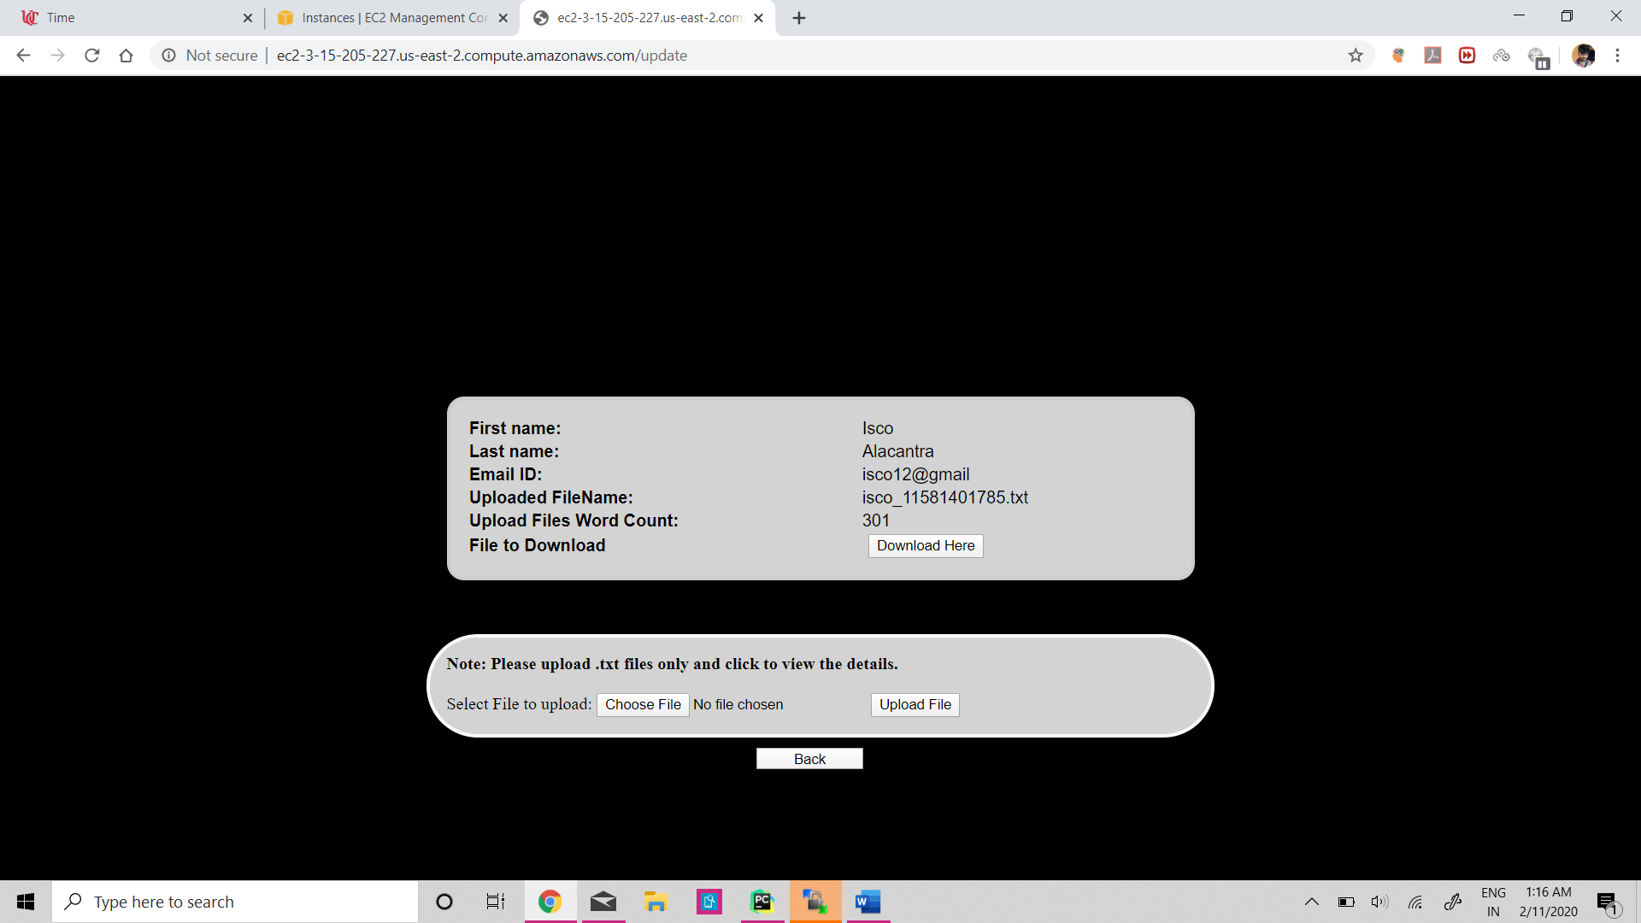

Clicking on back button goes again to login page

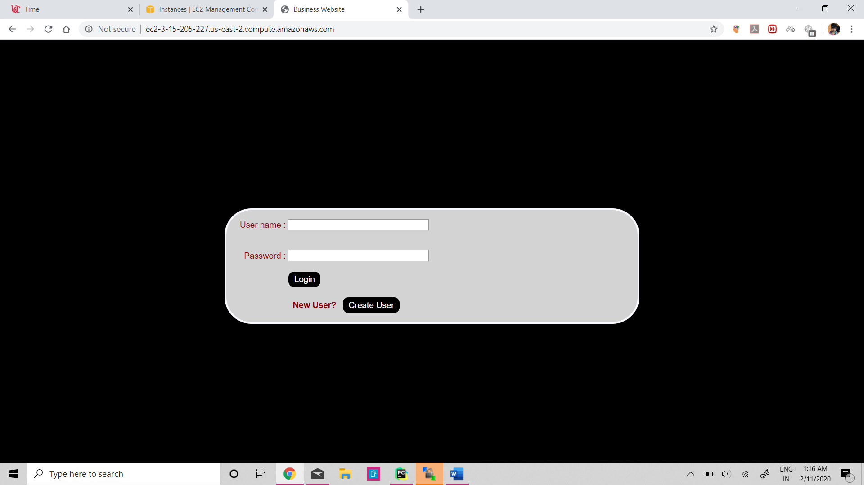

Below shows the screen after clicking on ‘Create User’ button

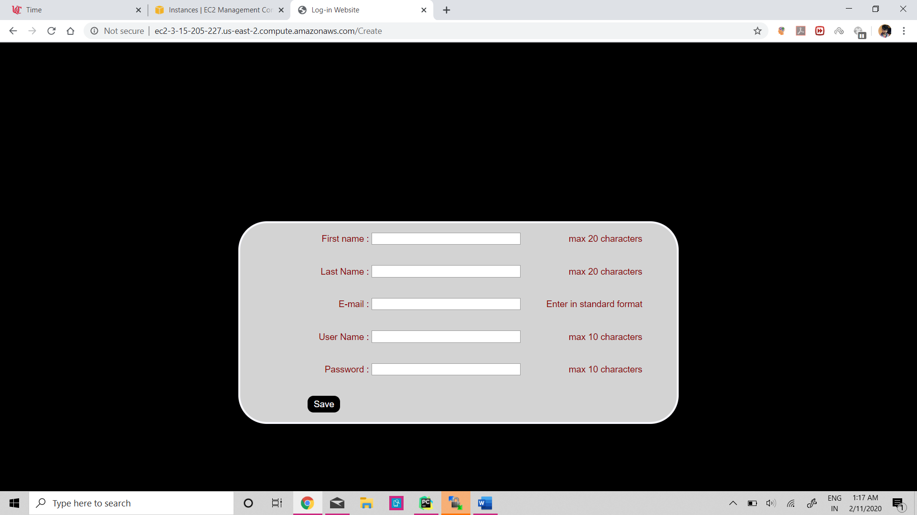

Below screenshot shows that values are entered

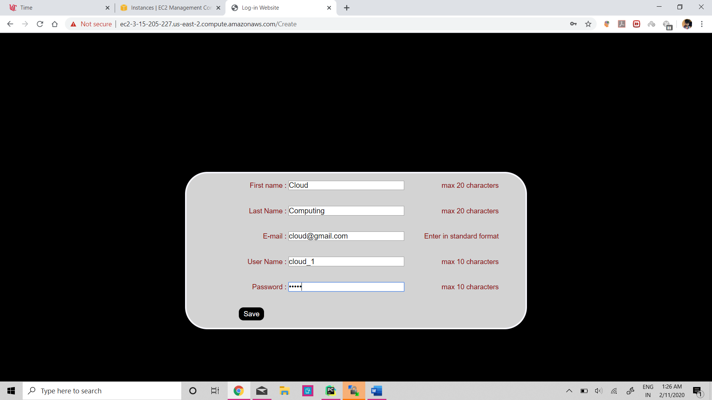

Below screenshot shows that the details are displayed after registering new user:

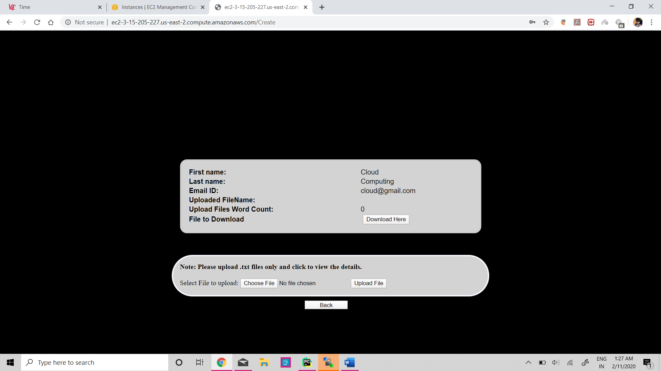

We can upload the file in here,

After uploading a file:

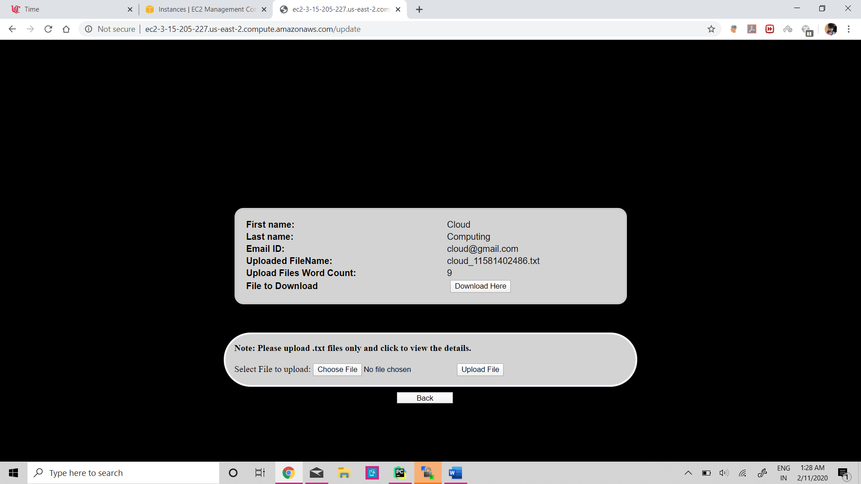

Download the file using download button

Screenshots of Code:

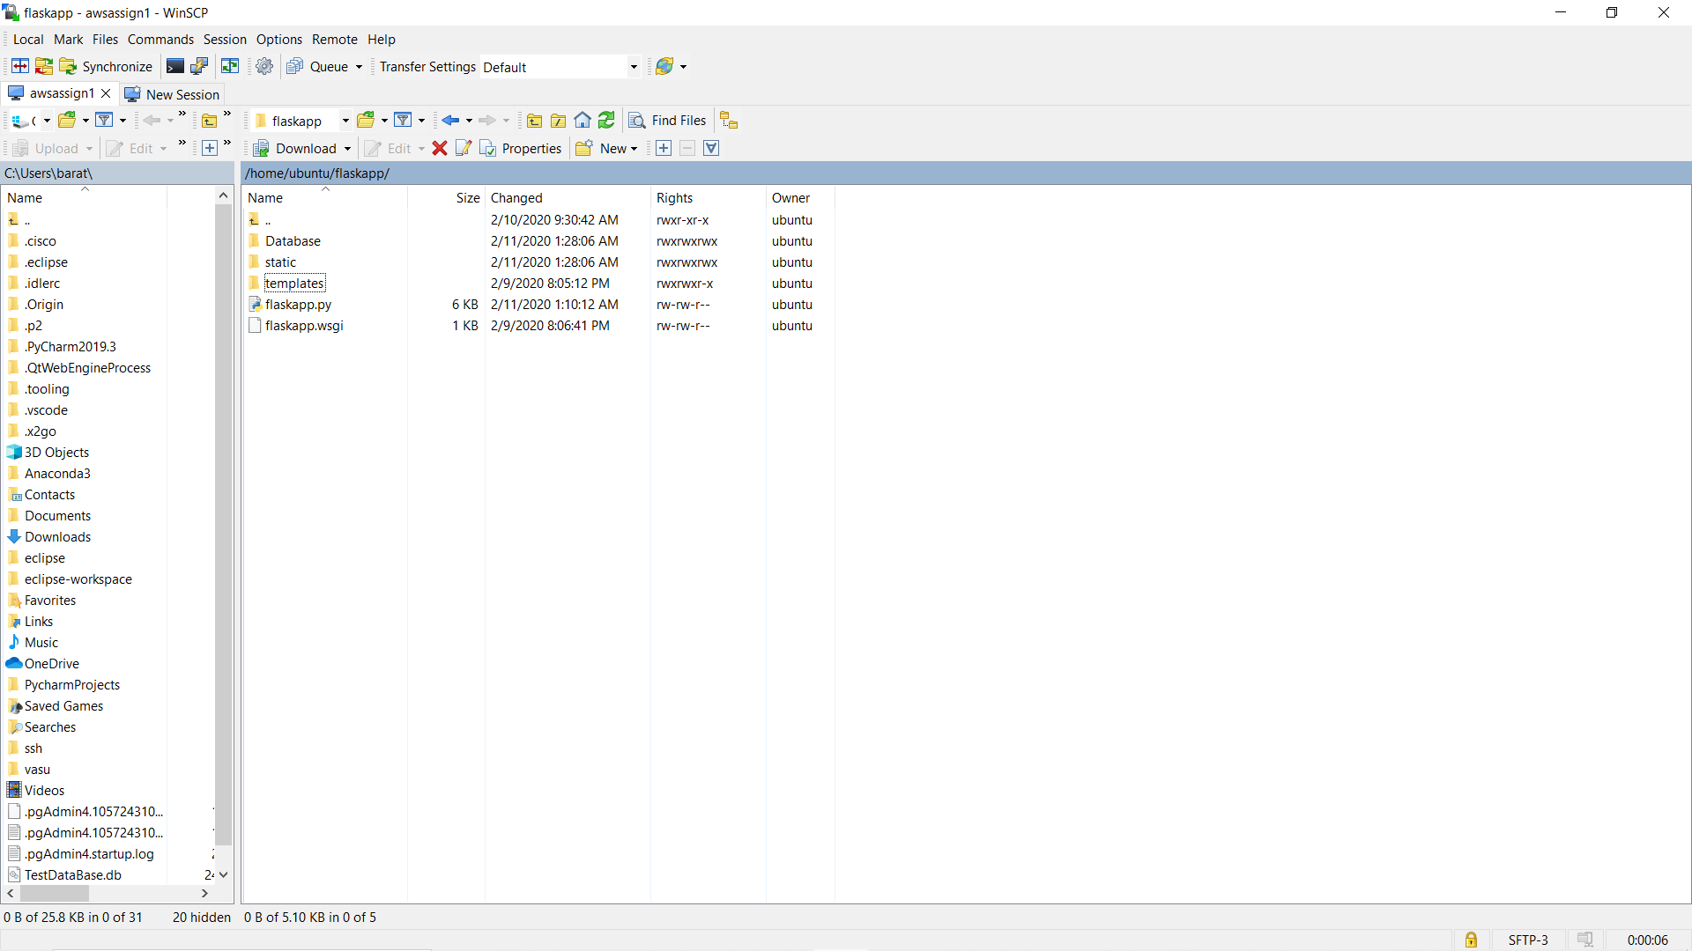

‘/’

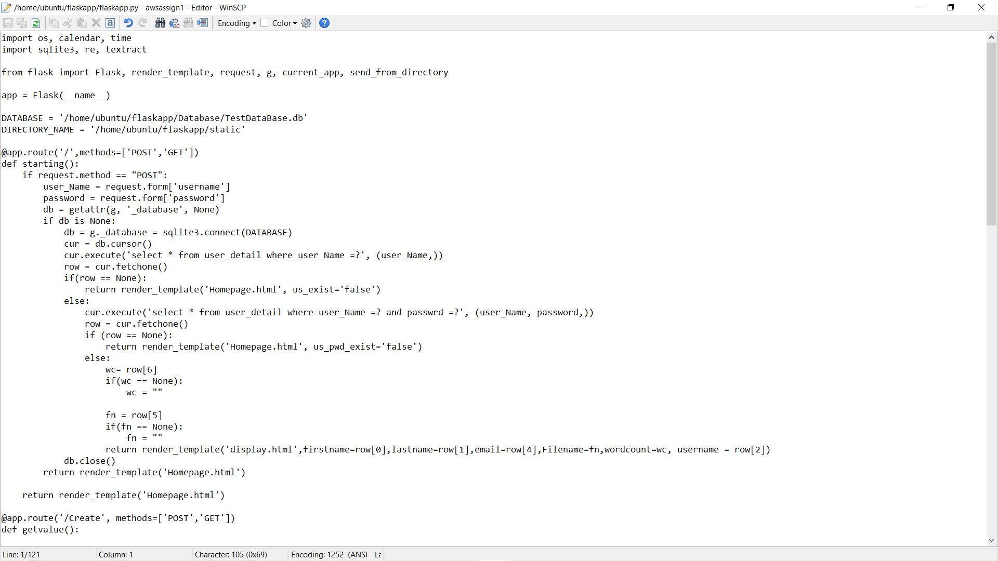

‘Create’

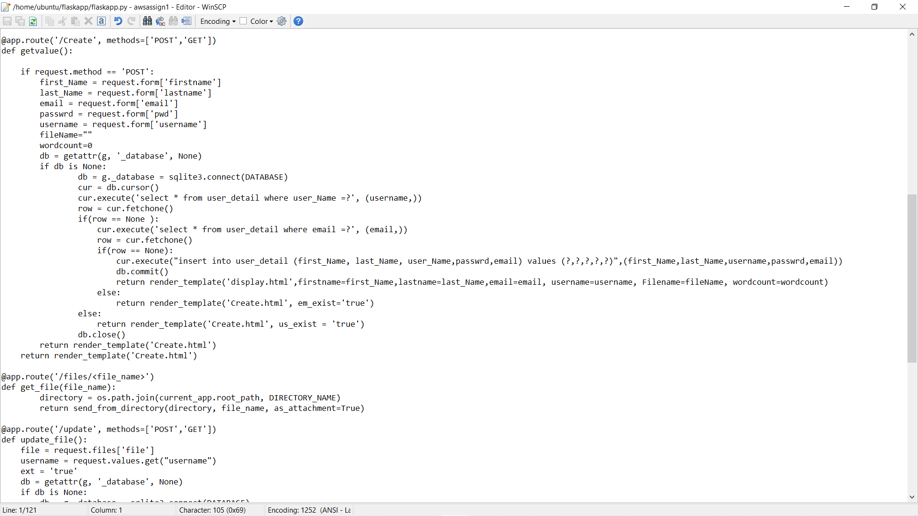

‘Files’ and ‘update’

